Full Title
-Subtitle (if necessary)-

Andy Chen and Bob Lin
Institute of Materials Science and Engineering, National Taiwan University

No.1, Sec. 4, Roosevelt Road, Taipei,10617 Taiwan

Below is an example of writing equations.
$U=Δ$ (1)
$G(E)=\frac{1−n}{E−E_{0}}+\frac{n}{E−(E_{0}+U)}$ (2)
Equation numbers are referred like this: Equation (2).

You can place figures as below.
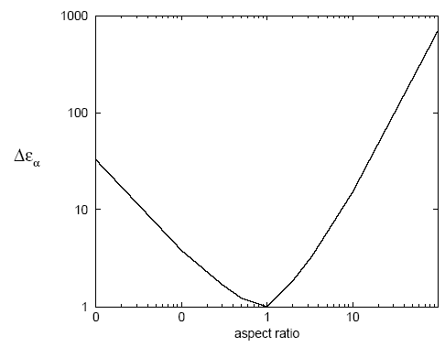
Figure 1 Caption of the figure.
You can write a table as below.
 | A | B | C
X | 1 | 2 | 3
Y | 1 | 2 | 3
Table 1: Caption of table.

Acknowledgment
You can place Acknowledgement here if you need.

References
[1] A. Chen and B. Lin, Soft Matter 2 (2006), 123.
[2] C. Chang, Phys. Rev. E 73 (2006), 0001213.

